Code Snippets
1.
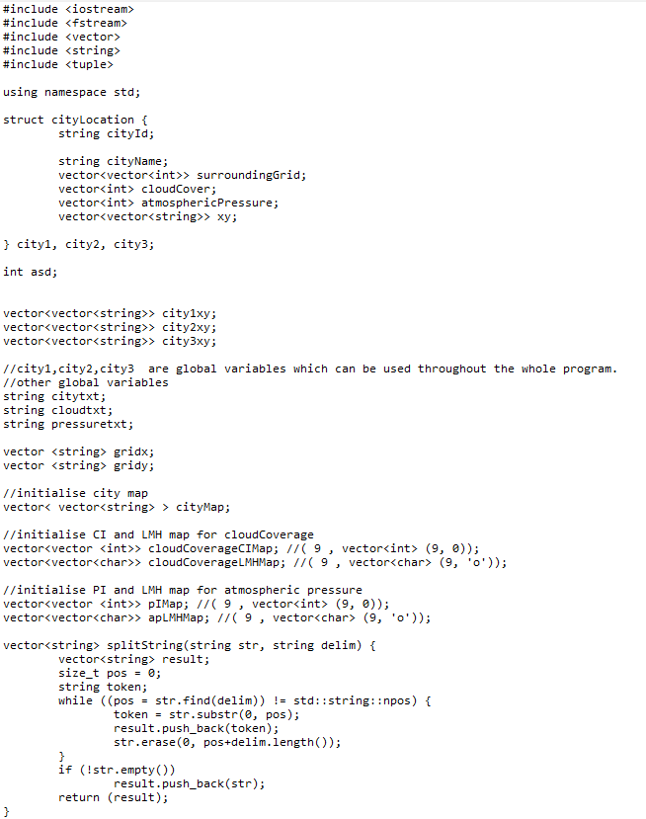

cityLocation struct datatype to acess individual city location. Id, name. citytxt, cloudtxt, pressuretxt are strings for each individual file names.
splitString function split string into vector datatype by delimiter.

2.
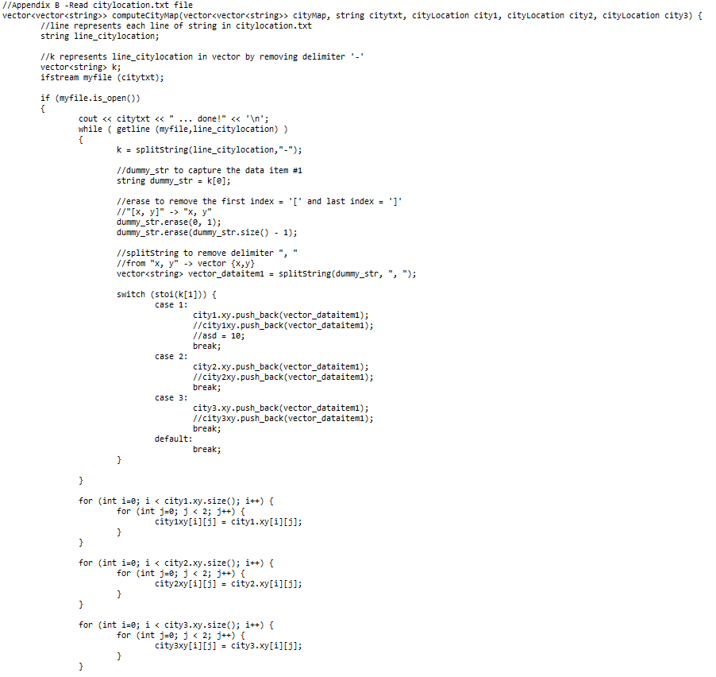
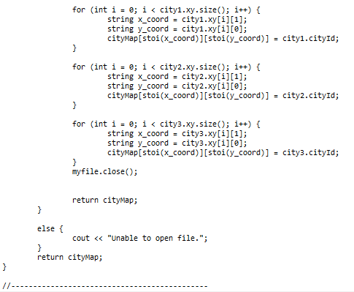
Code snippet shows Appendix B. Opens citylocation.txt file. Prints done when opened. Appends x and y axis into city1.xy, city2.xy, city3.xy respectively according to citylocation.txt file.
3.
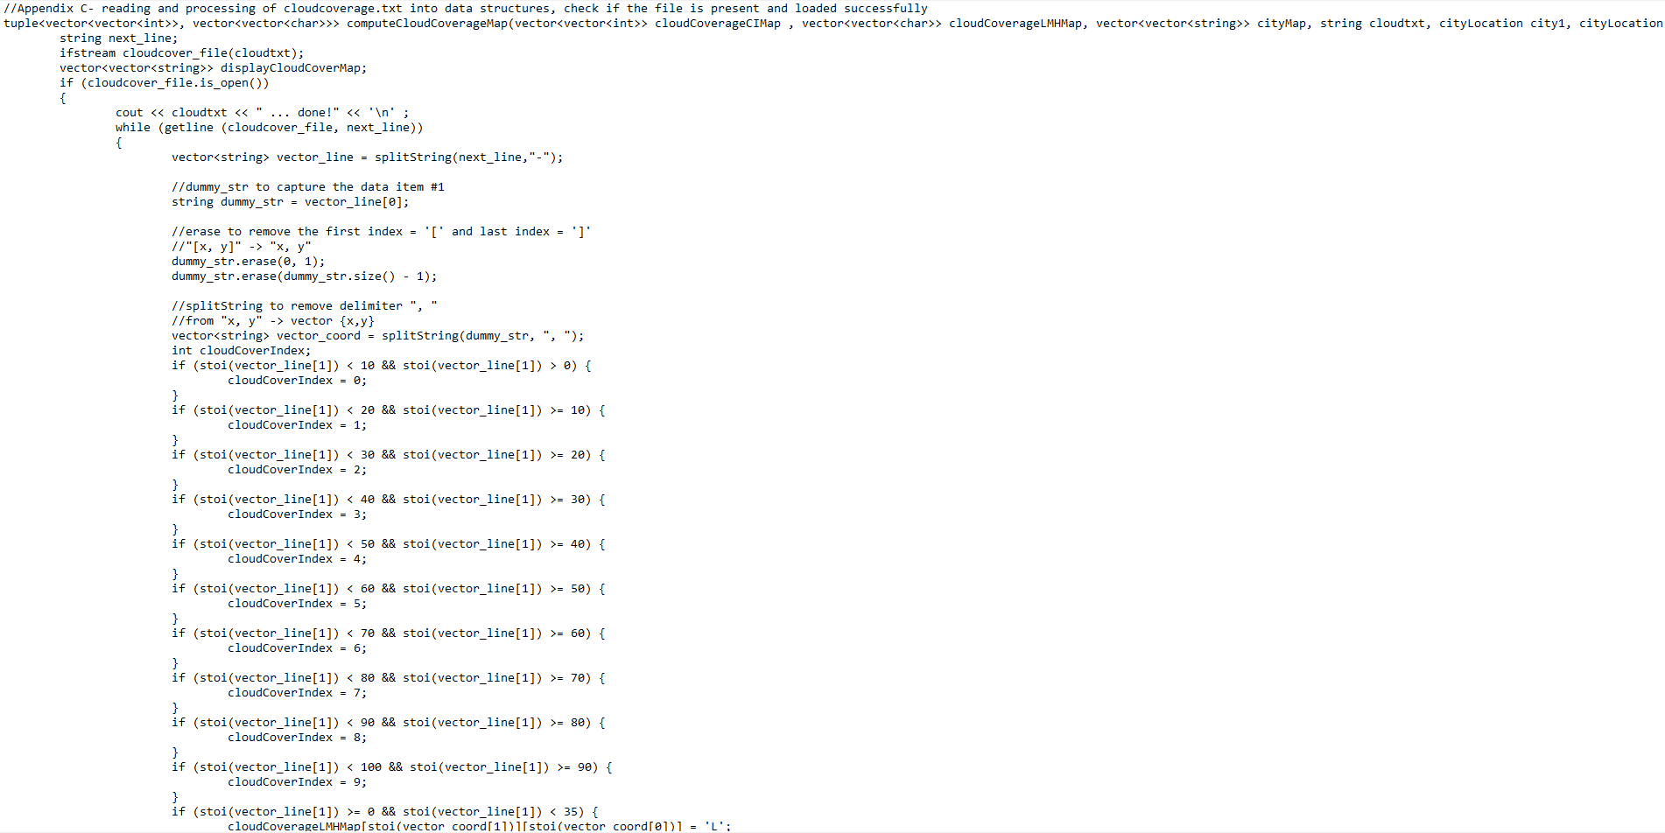
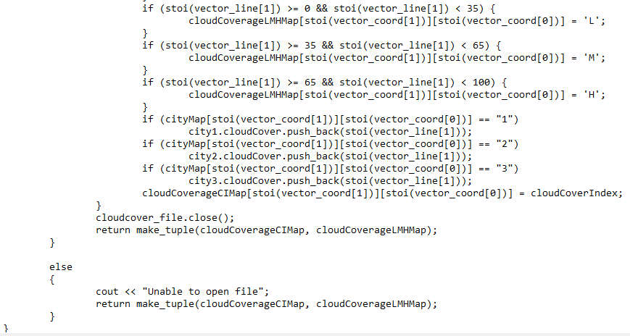
Appends cloud coverage index and low/mid/high symbols into respective vectors.

4.
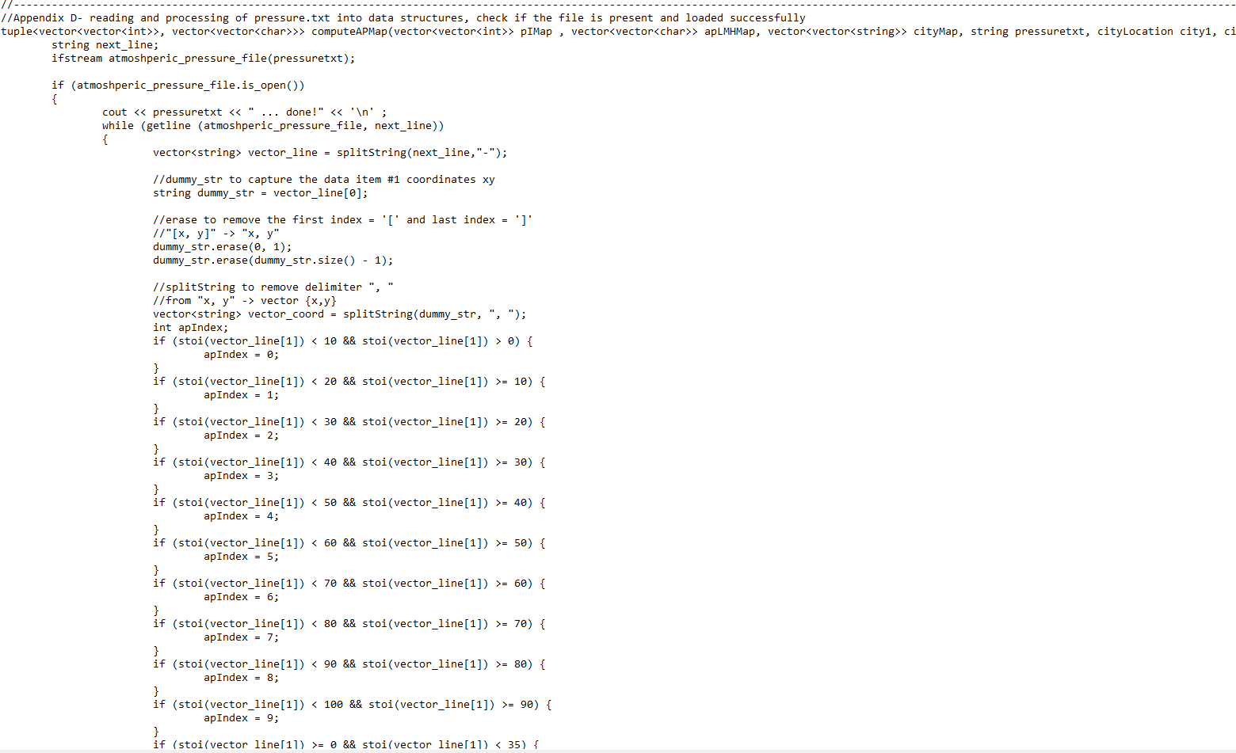
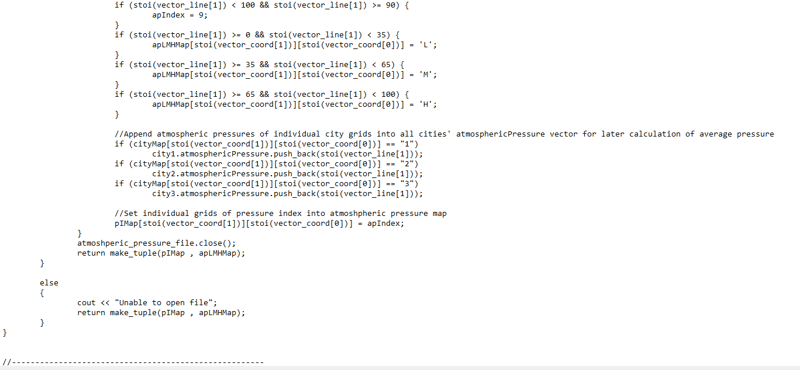
Appends atmospheric pressure index and low/mid/high respective symbols into vectors.

5.
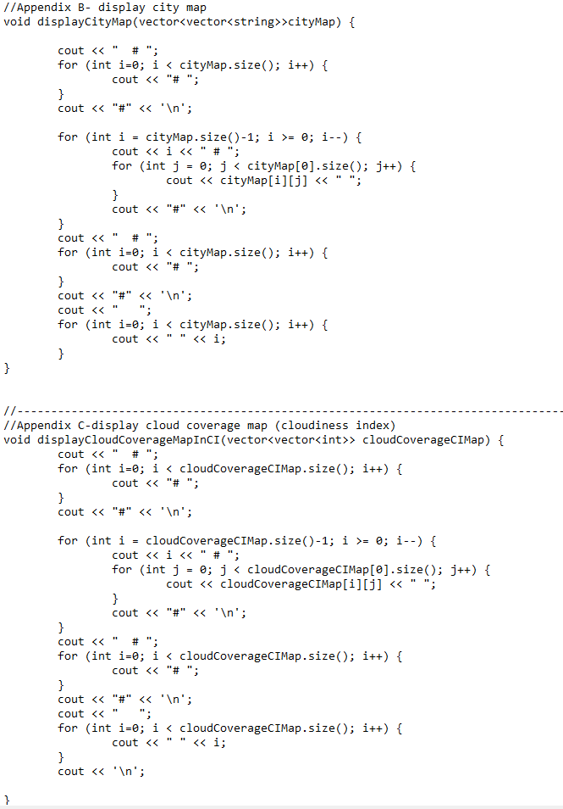
DisplayCityMap function displays grids of the map, showing each and individual city location.
DisplayCloudCoverage function displays grids showing individual tiles’ cloud coverage in index form.
6.
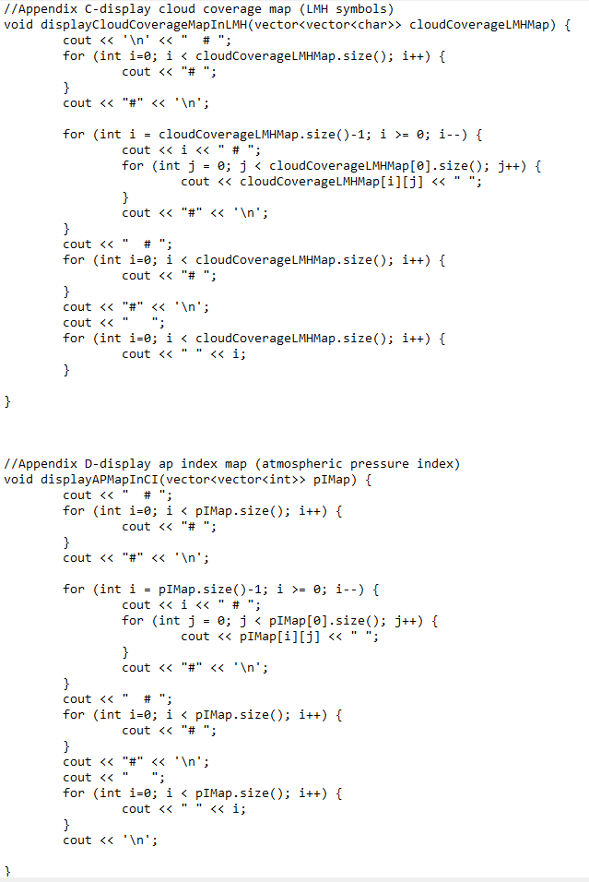
DisplaycloudcoverageInLMH function displays grids showing individual tiles’ cloud coverage in LMH.

7.
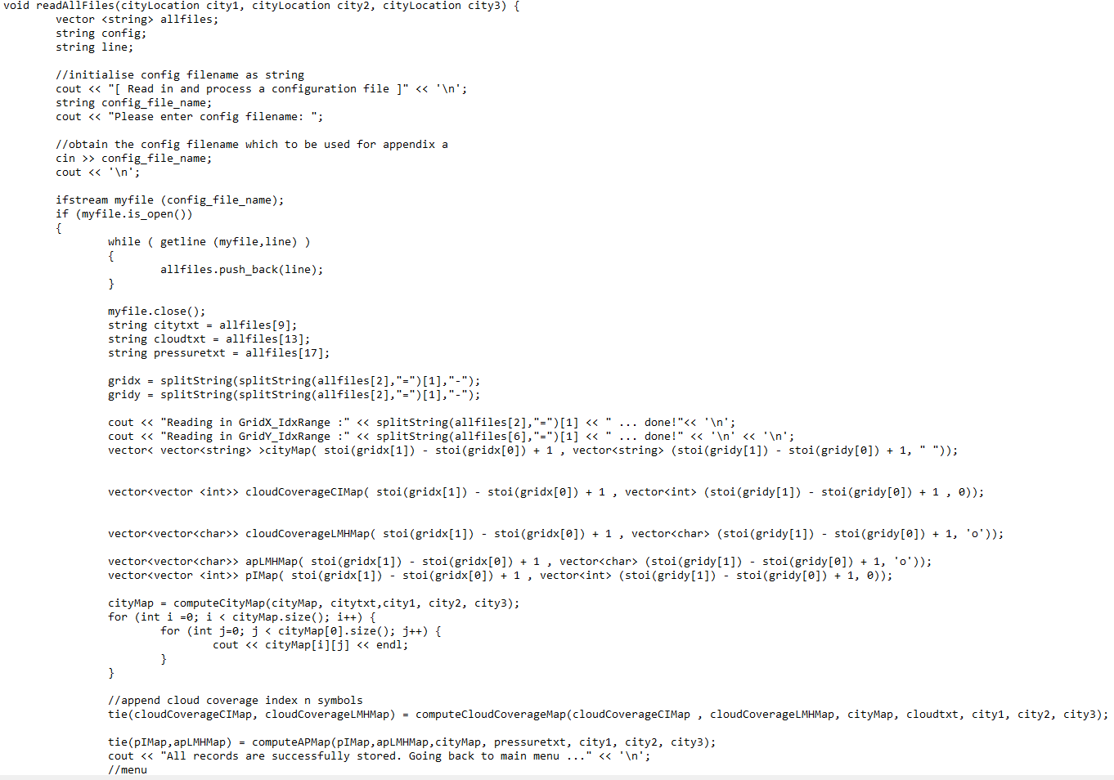

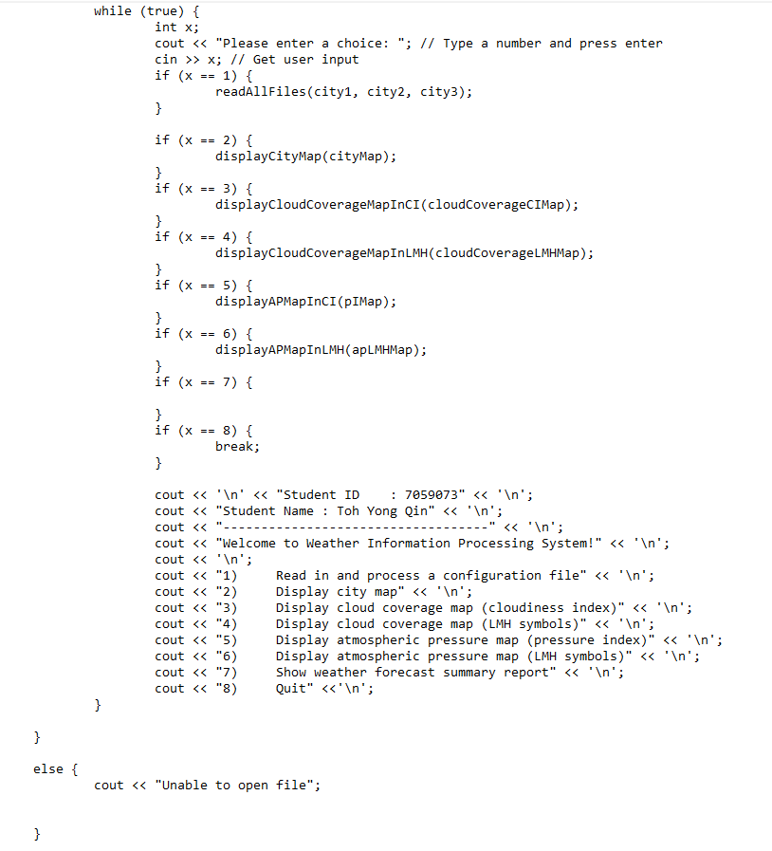
This function reads config.txt, runs all files to capture all contents into vectors, display them in grids, and also gets user input at the main menu.

8.
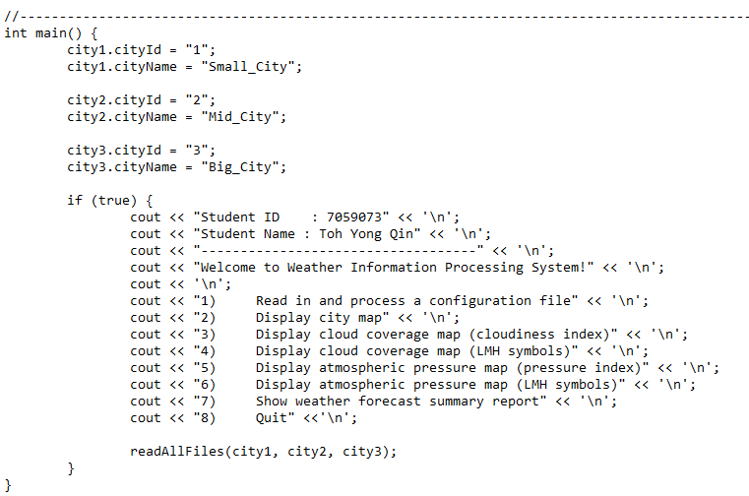

Main function prints out the main menu for the first time.

Reflection
Assumptions made:
-there are 3 cities.

Difficulties faced:
-new to c++
-too much arrays/vectors with nested and global variables making things hard to debug.

Possible enhancements:
-Program that accepts more than 3 cities

What have I learnt:
-Understanding of c++ concepts and how it defers from other languages.

